Setup Ubuntu Server (on Virtual Box)

* 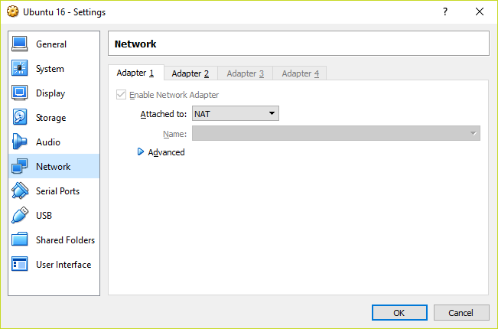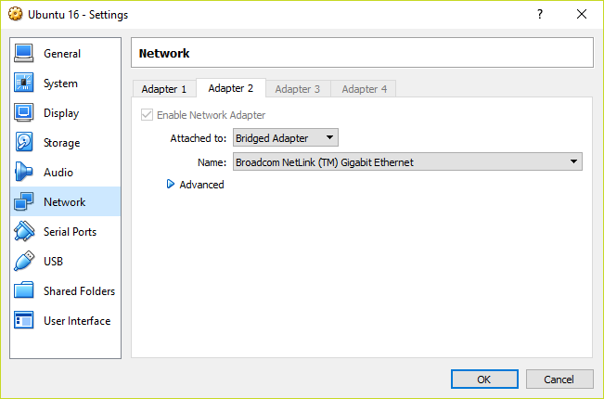Activate the Network Bridge Adapter!

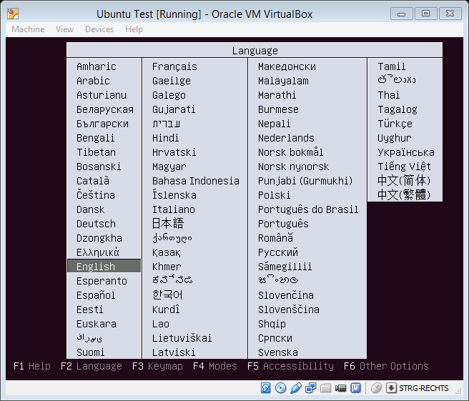

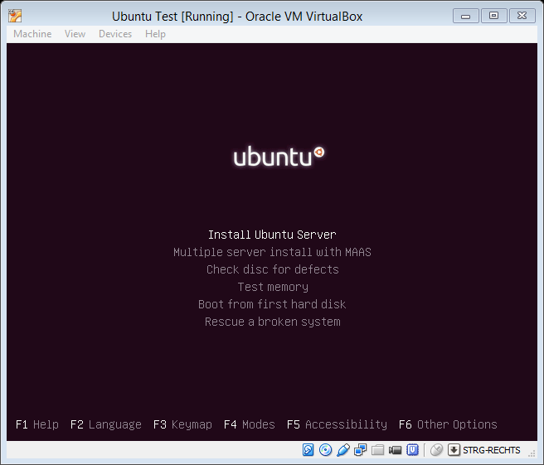

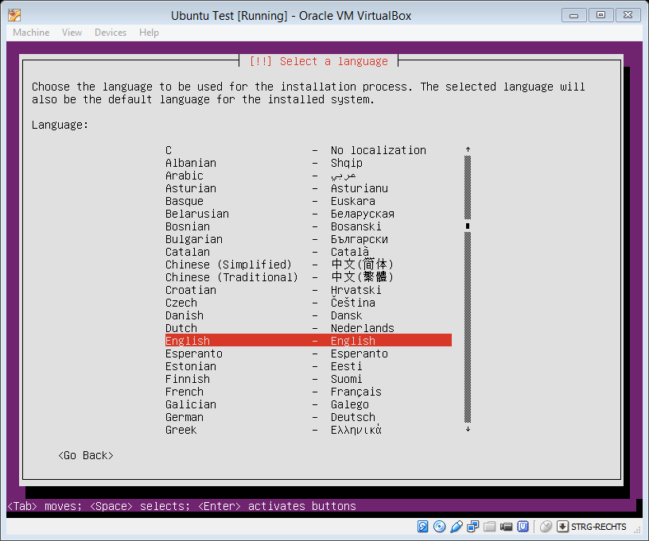

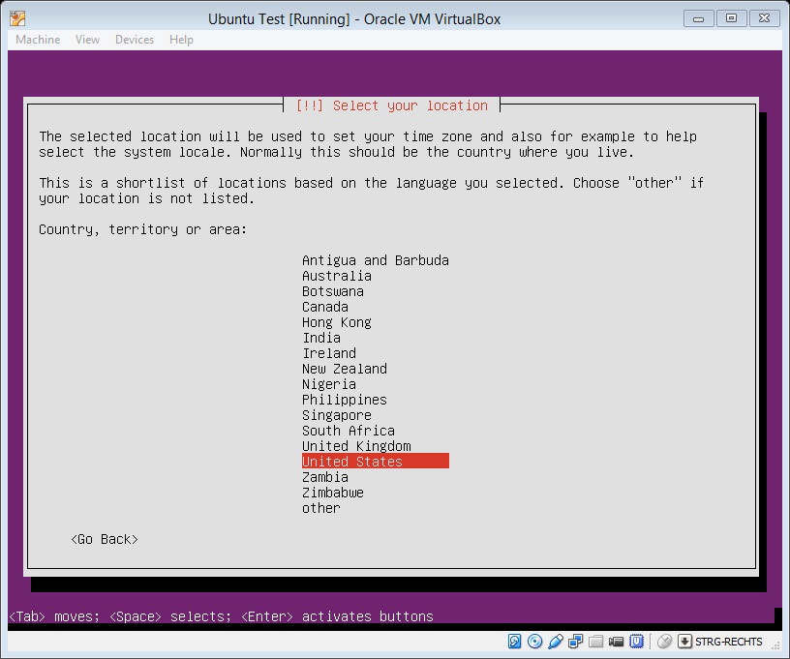

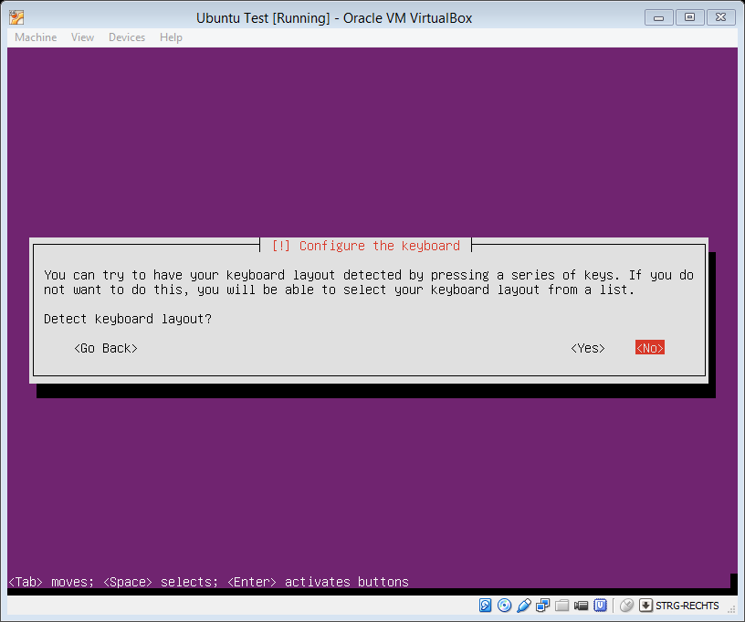

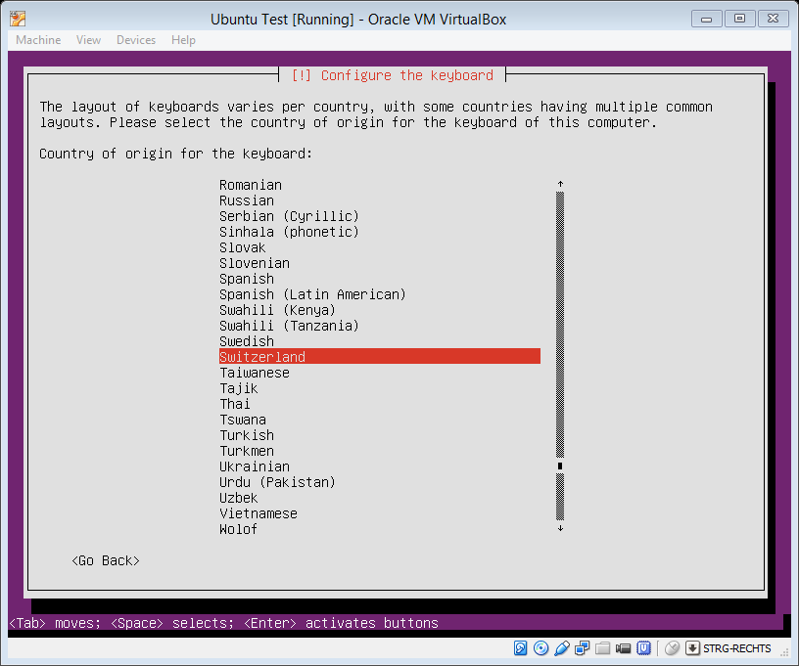

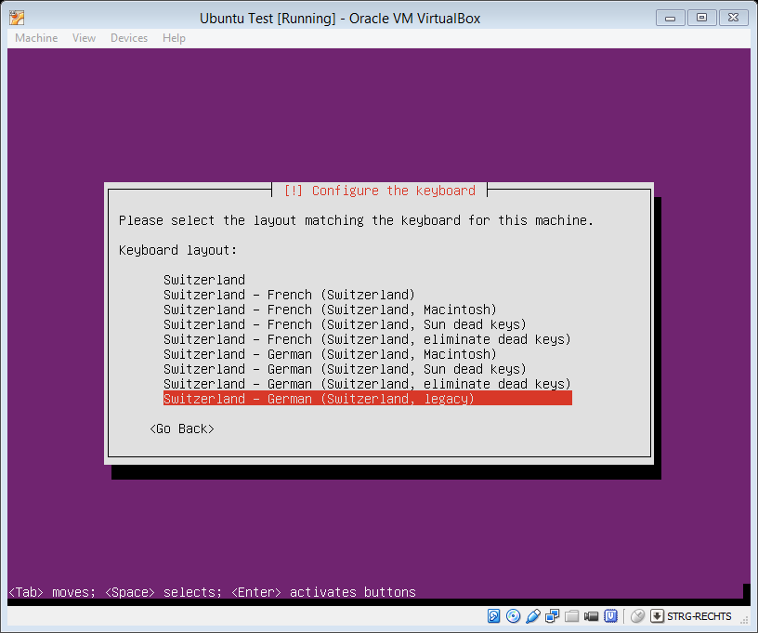

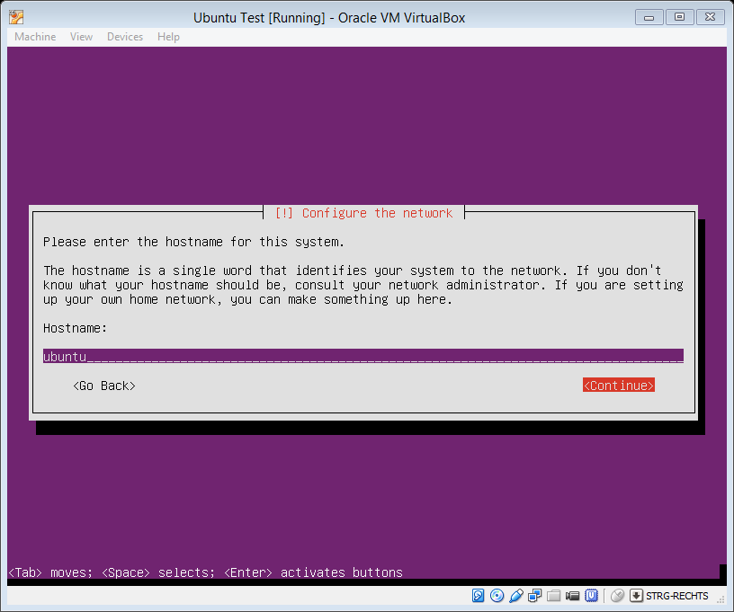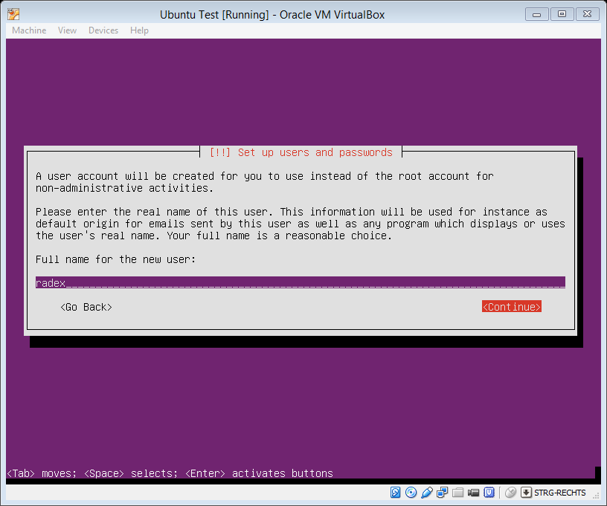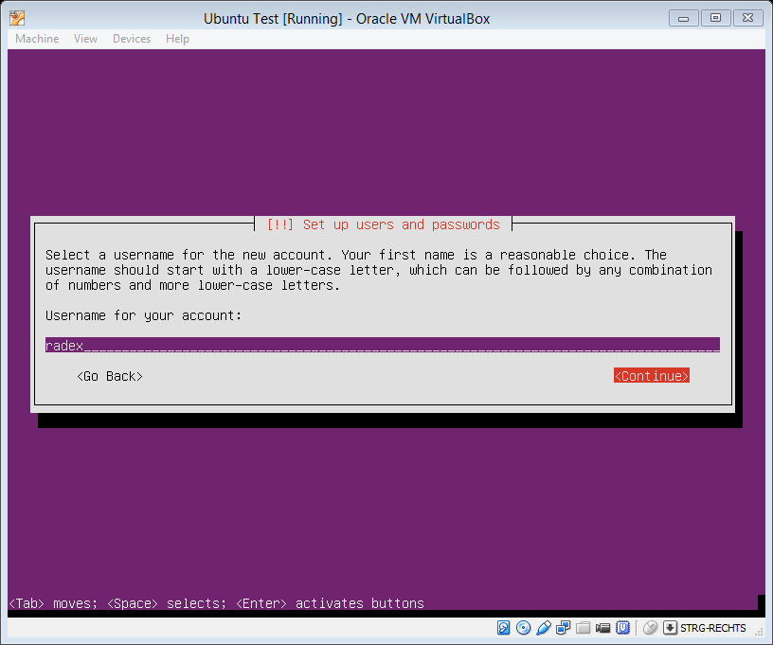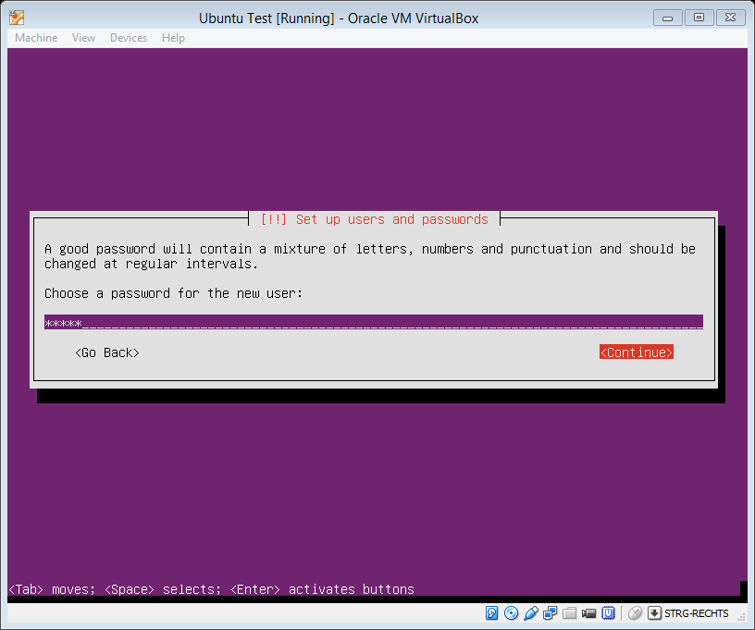Password “radex”

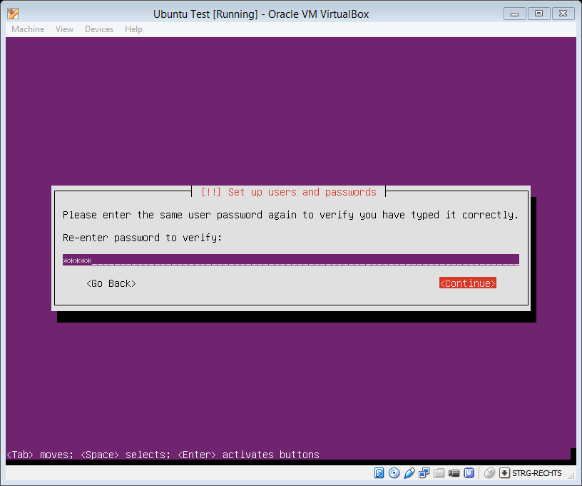

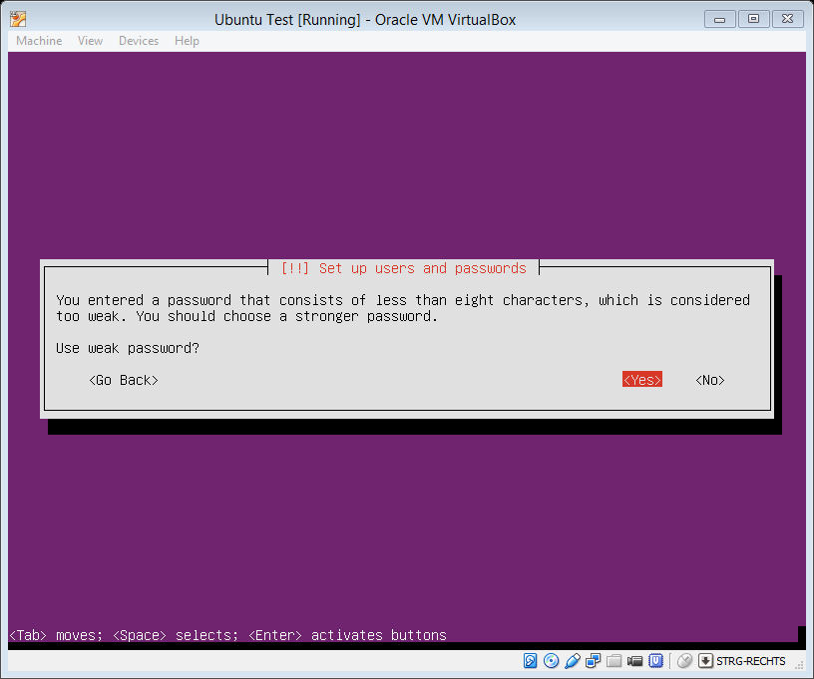

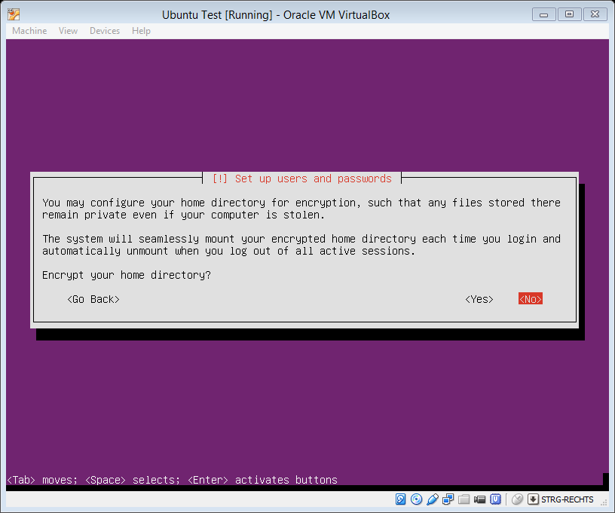

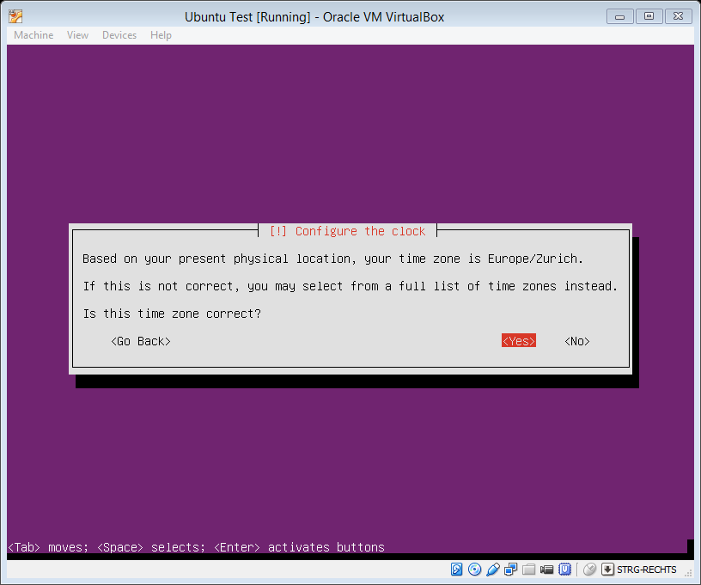

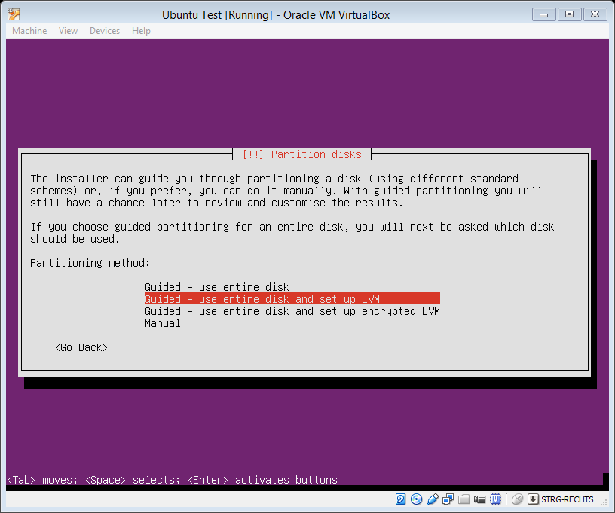

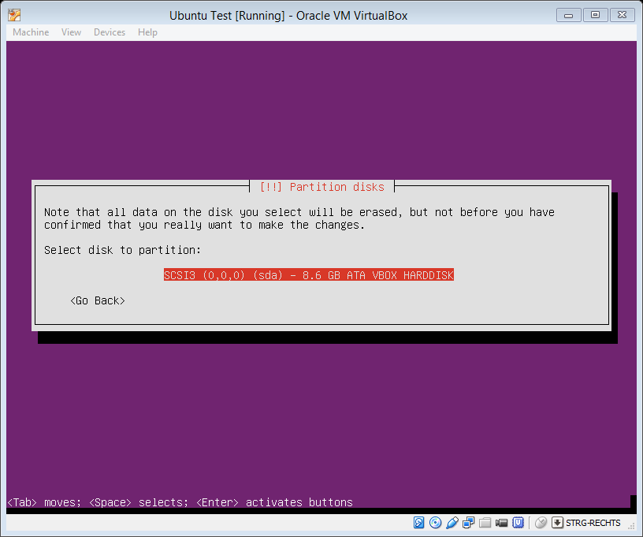

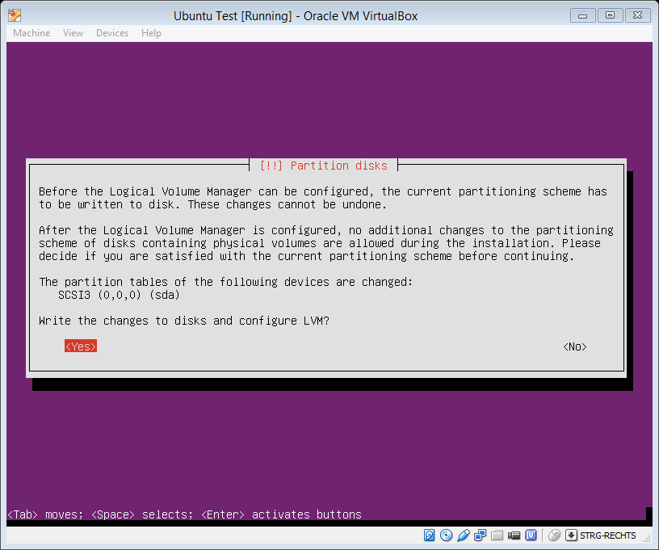

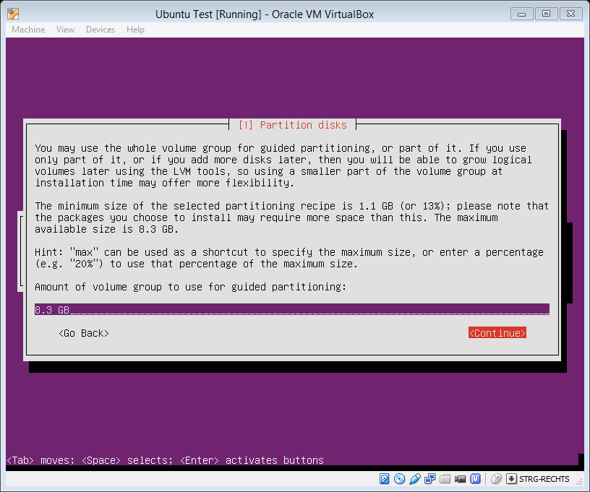

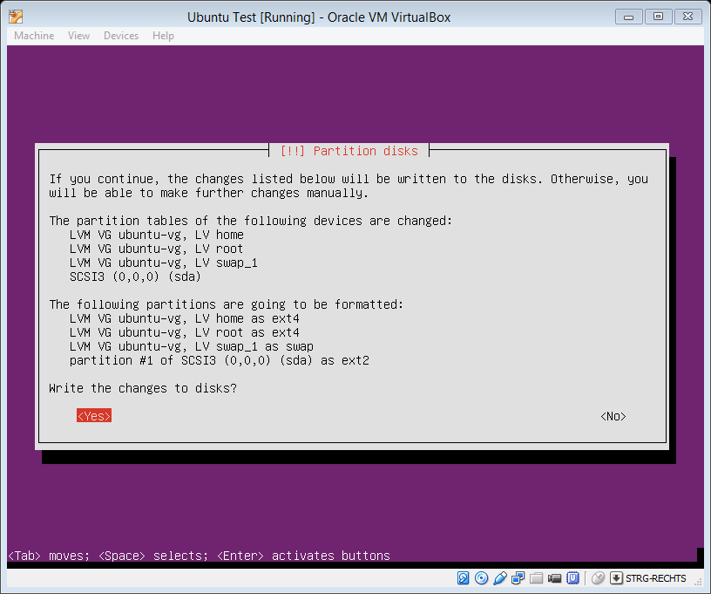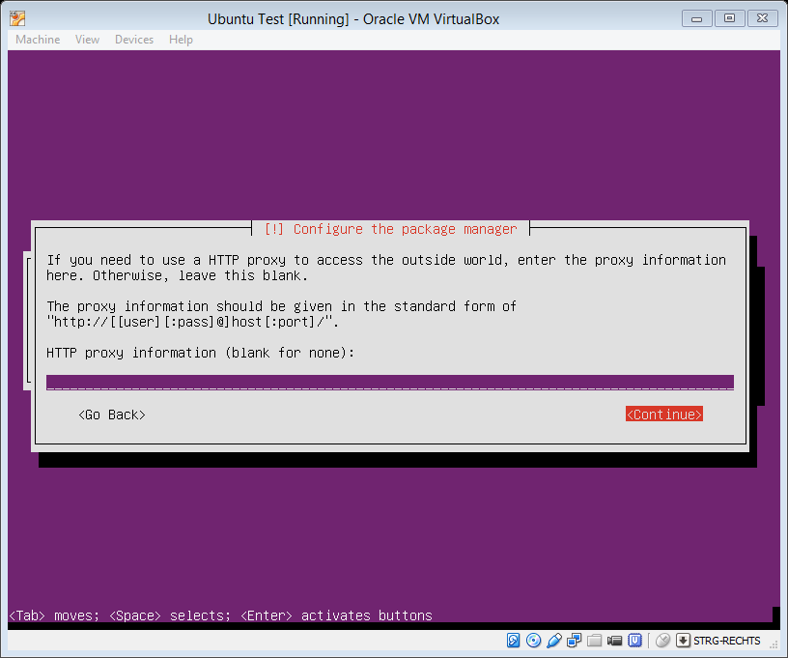

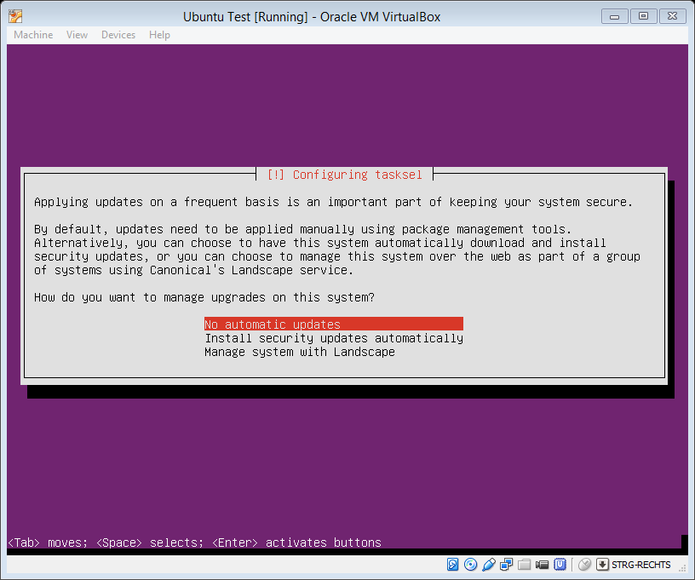

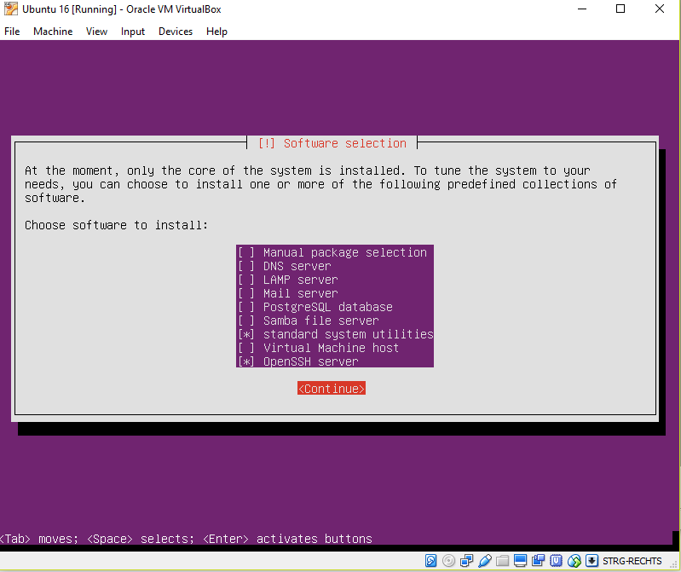

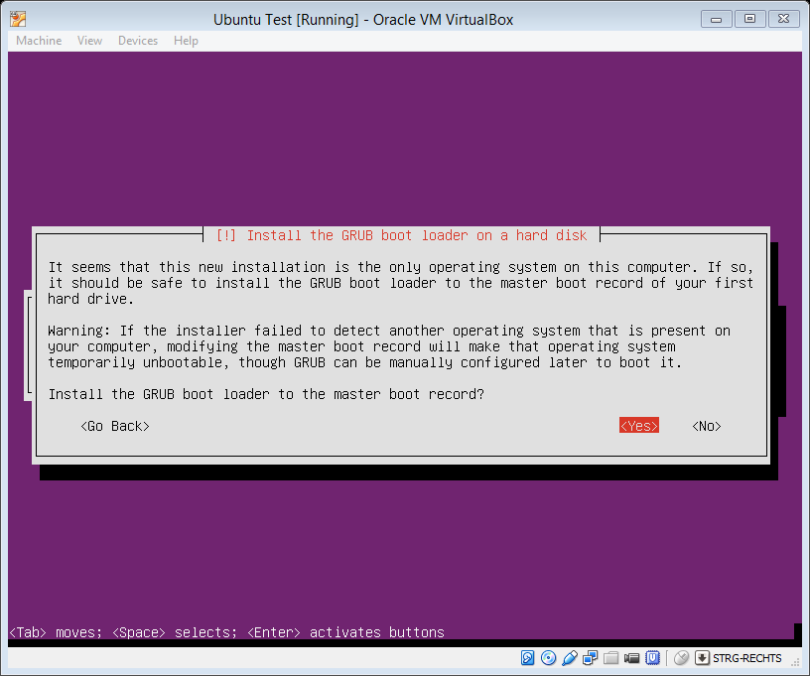

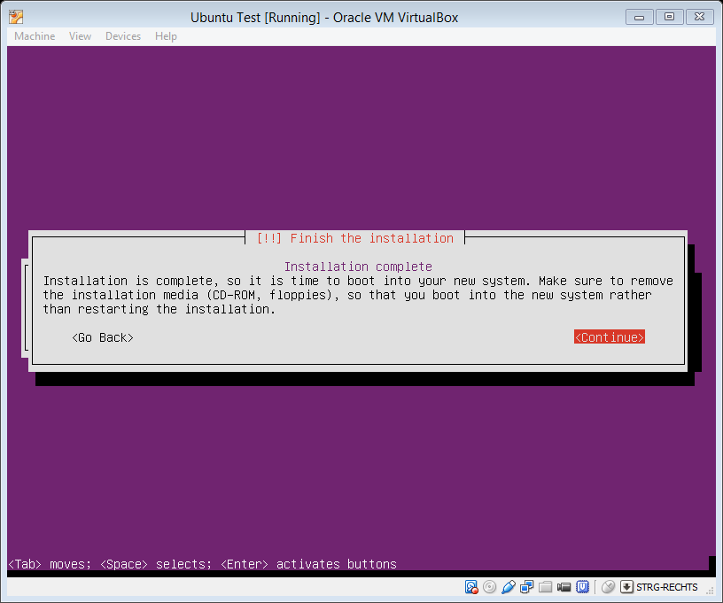

* sudo -i
* sudo passwd root
  + radex
* reboot
* apt-get update && apt-get upgrade
* apt-get install build-essential gdbserver

/etc/network/interfaces

* auto eth0
* iface eth0 inet static
* address 192.168.200.126
* netmask 255.255.255.0

Ab V14: Open SSH for root:

* sudo nano /etc/ssh/sshd_config
* *sucht nach der Zeile (STRG + W ist Suchen) nach*
* PermitRootLogin without‐password
* *und setzt ein # davor:*
* #PermitRootLogin without‐password
* *Speichert die Datei und startet den ssh Dienst neu:*
* sudo service ssh restart

Ab V16: Open SSH for root:

* sudo nano /etc/ssh/sshd_config
* *sucht nach der Zeile (STRG + W ist Suchen) nach*
* PermitRootLogin prohibited‐password
* *und setzt ein # davor:*
* PermitRootLogin yes
* *Speichert die Datei und startet den ssh Dienst neu:*
* sudo service ssh restart

Create alias to restart SSH server:

* *Open file «~/.bash_aliases»*
* *Add following line:*
  + alias ss='sudo service ssh --full-restart'

Windows Linux Subsystem:

1. sudo apt-get remove openssh-server
2. sudo apt-get install openssh-server
3. sudo nano /etc/ssh/sshd_config and disallow root login by setting PermitRootLogin no
4. Port 2222
5. Then add a line beneath it that says:

AllowUsers yourusername

and make sure PasswordAuthentication is set to yes if you want to login using a password.

1. Disable privilege separation by adding/modifying : UsePrivilegeSeparation no
2. sudo service ssh --full-restart
3. Connect to your Linux subsystem from Windows using a ssh client like PuTTY
4. Copy Libraries from “Win-Linux-SubSytsem usr.zip”:

|  |  |  |  |
| --- | --- | --- | --- |
| /usr |  |  |  |
|  | /lib |  |  |
|  |  | libmatrix64.so |  |
|  | /local |  |  |
|  |  | /lib |  |
|  |  |  | libmlpi.so  libtbarcode11.so |